INSTRUCTIONS FOR SIGNING UP FOR AN NRG ON-LINE EVENT
(VIRTUAL WORKSHOPS, ANNUAL MEMBERSHIP MEETING, ETC.)

Since we started using the on-line registration system for attending the NRG Virtual Workshops, there has been some confusion. This will explain the registration process. It is suggested that you save this explanation so it can be referred to for later events.
Members will get an email like the image below as their first notification of an upcoming event. The email may cover several subjects, but it will be in the format we have been using for several years with our logo and name at the top. Depending on the event you might receive more than a single announcement in this format. There is nothing to do now except to mark your calendar to remember the upcoming event.
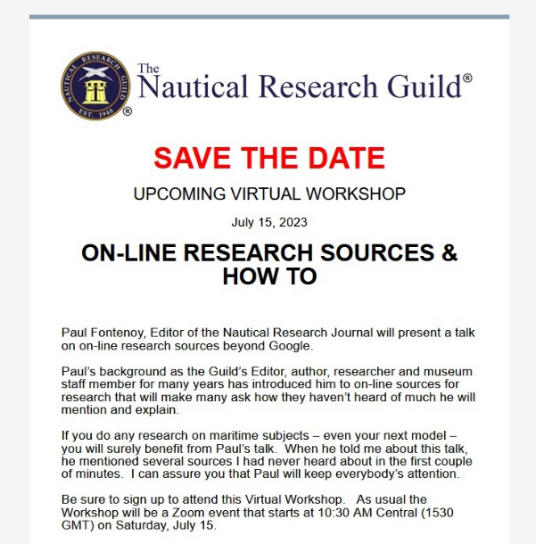

When registration opens for the event, you will receive an email with the event details. This email is generated by our management system and the sent from address shows as Nautical Research Guild <NauticalResearchGuild@wildapricot.org> the @wildapricot.org has caused some to think the email was hacked. It is legitimate.

Next is an email as shown below. There is a green REGISTER button to click on if you plan to attend and a white NOT ATTENDING button to click if you will not be attending. Caution: If you are unsure if you will or can attend do not click on either button until, you are sure. If you click on the NOT ATTENDING button and later wish to attend it will take the assistance of the NRG Office to get registered and it must be done during regular office hours.
Instructions for proceeding are printed out on the lower half of this email.
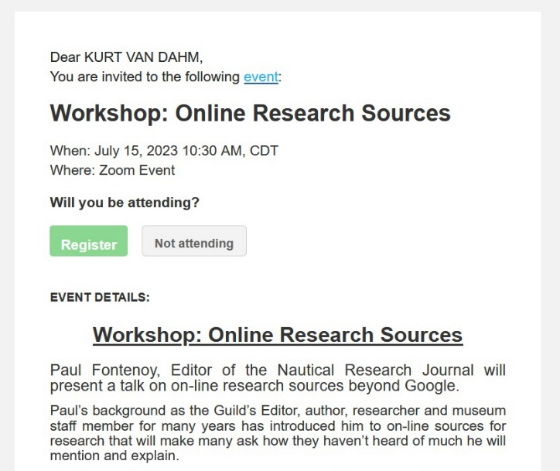

When the REGISTER button is clicked you will receive another email with a form to fill out with your personal information that will match your membership records in our database. Fill it out completely and check both boxes under where your email is to be listed. If you do not check the boxes your registration will not go through. Click on the NEXT button.
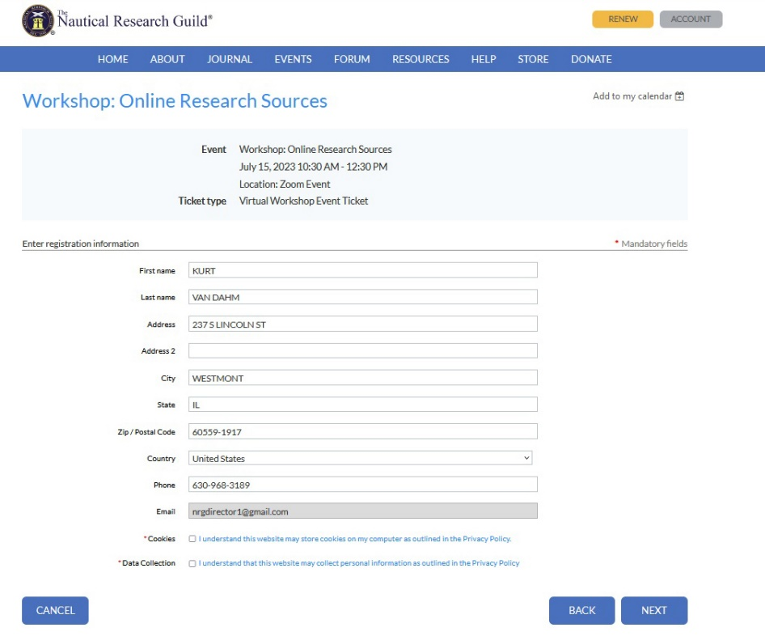
You will then get another email with a light blue banner across the screen saying, “Review and Confirm.” Review all the information and if necessary, go back by clicking the BACK button to make any needed corrections and when you have verified that the information is correct click CONFIRM.

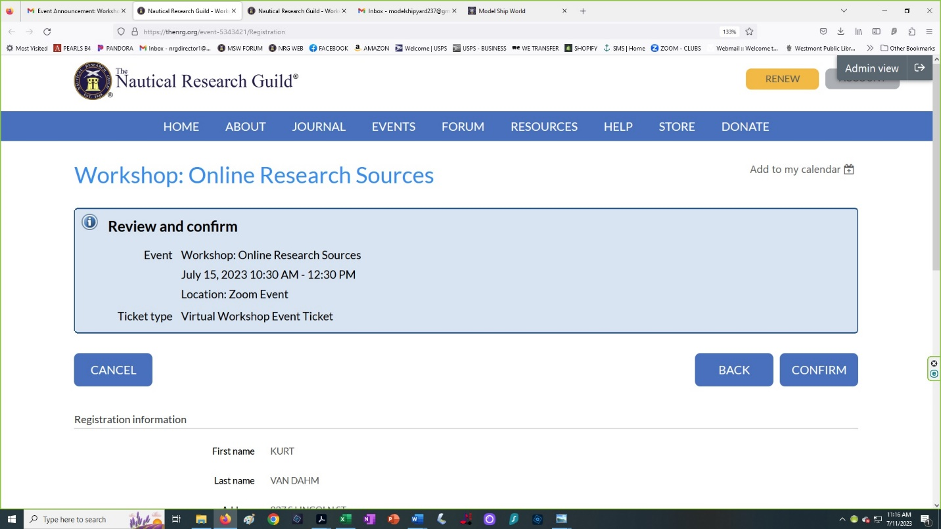

You will next receive an email with your REGISTRATION CONFIRMATION RECEIPT. Either print this email out or mark in so you can find it later in your In Box in case it is needed later. Your registration is now complete.

The last email you will receive should arrive shortly after completing the steps described above. The time will vary due to how busy the system may be, but it will arrive within a few minutes. SAVE this email as it contains the ZOOM link to use the day of the event. Five (5) minutes before the event’s start time click on the ZOOM link. Make sure your speakers are working – use the ZOOM test feature – if you are asked to turn off your video camera do so when requested so band width can be conserved as we sometimes get well over 100 members attending.

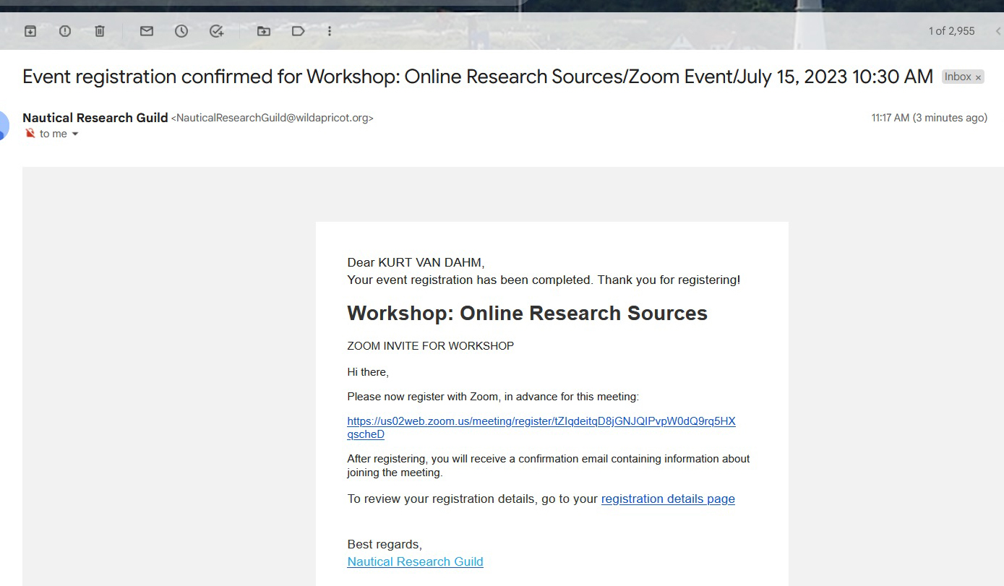

Sit back and enjoy the presentation.

Thank you,
The NRG Virtual Meetings and Workshop Committee

